Upgrading a legacy ReadyNAS from RAIDiator 4.2.x to 6.x
How to upgrade a legacy x86 based ReadyNAS to OS 6.x
June 25, 2015 Myles Gray | Suggest Changes
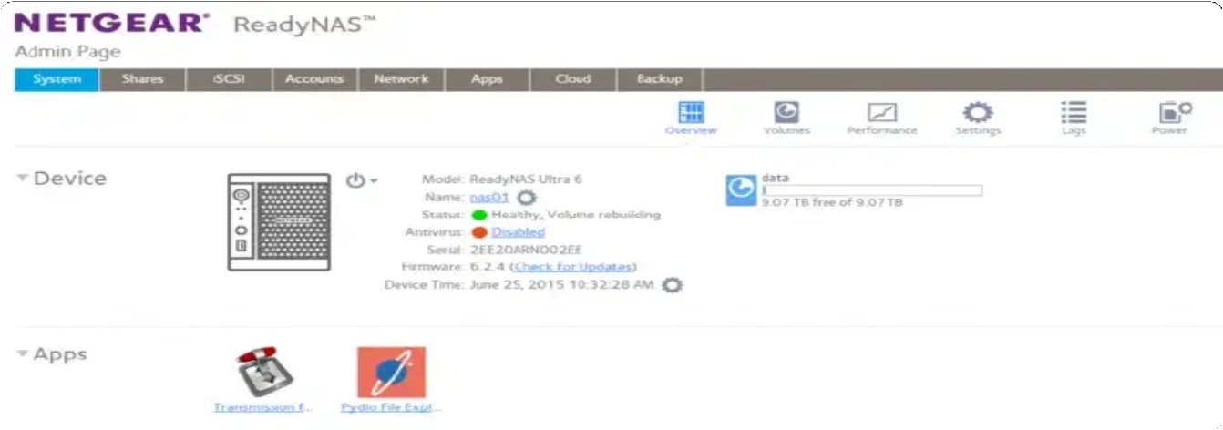

My old ReadyNAS was in need of an update and figured i’d look back into upgrading to OS 6.2.x again, this used to be quite an involved manual process requiring you to access the VGA header on the motherboard ↗.
As it turns out Netgear have realised people would get round this anyway and have provided an (unsupported) upgrade path.
This will allow us to use a number of features not available on our current firmware (for me I have a ReadyNAS Ultra 6):

AD Authentication NFS v4

Native link bonding (without 3rd party plugin) SSH access (without 3rd party plugin)
New plugin catalogue

A shiny new GUI :)

N.B: This operation will factory reset your NAS including all shares, take a backup first! There is always a risk of bricking your device, I hold not responsibility for your actions or outcomes as a result of following this piece, use your own judgement, it’s your responsibility.
So, first things first, download R4toR6_Prep_Addon.bin and R4toR6_6.9.5.bin from the here ↗.
Log into your ReadyNAS admin interface and navigate to Add-ons -> Add New , Select the R4toR6_Prep_Addon.bin extension we downloaded earlier and click Upload and verify image... :
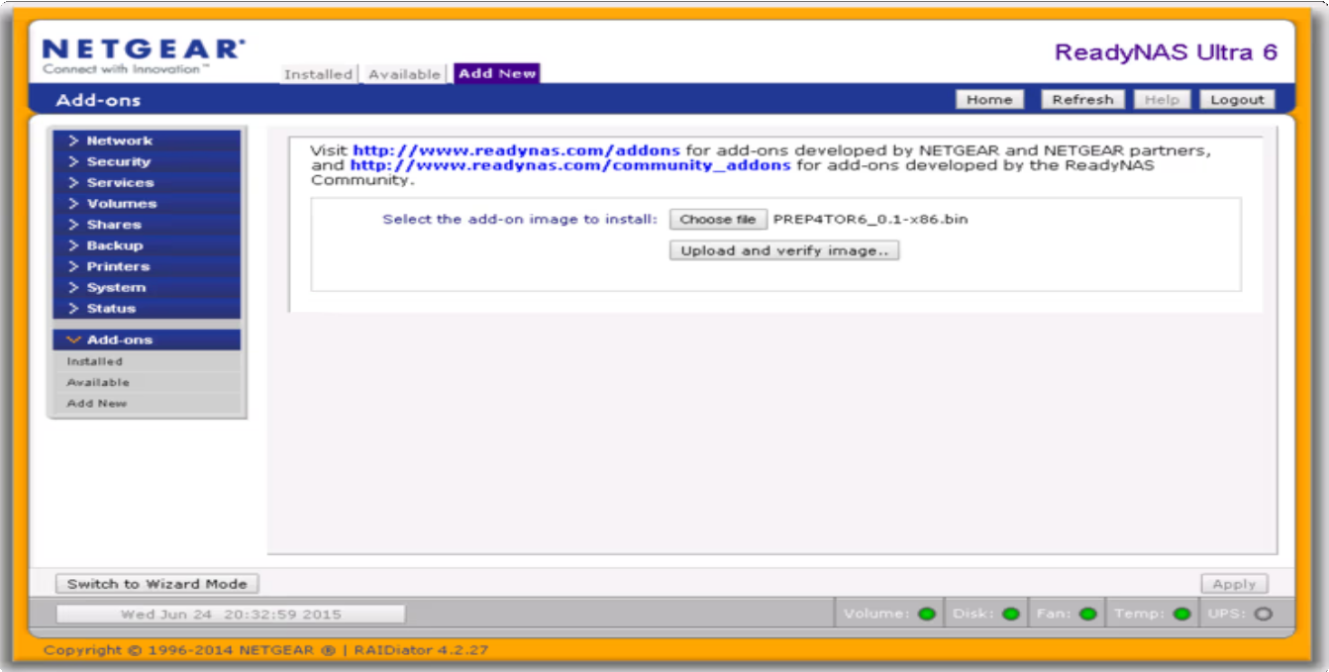
If the installation prep file was successfully uploaded and verified you will see the below:

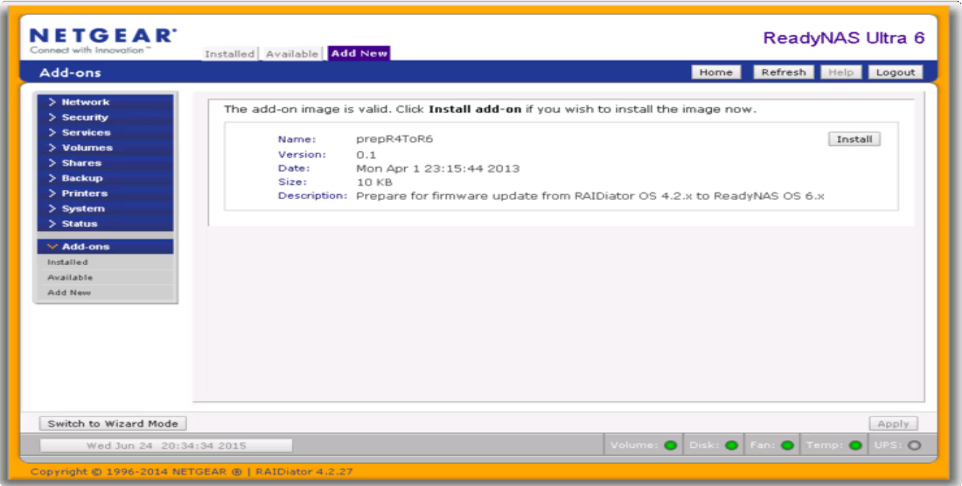

Click Install to commit to the OS.

Next up we need to upload the OS R4toR6_6.9.5.bin itself via System > Update > Local :

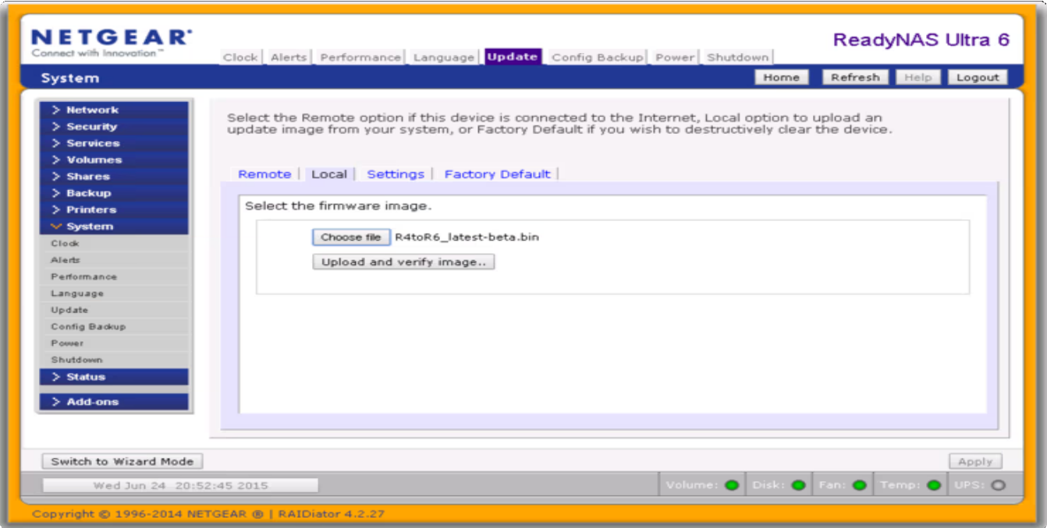

After the firmware has been uploaded and verified click Perform System Update and reboot when prompted:

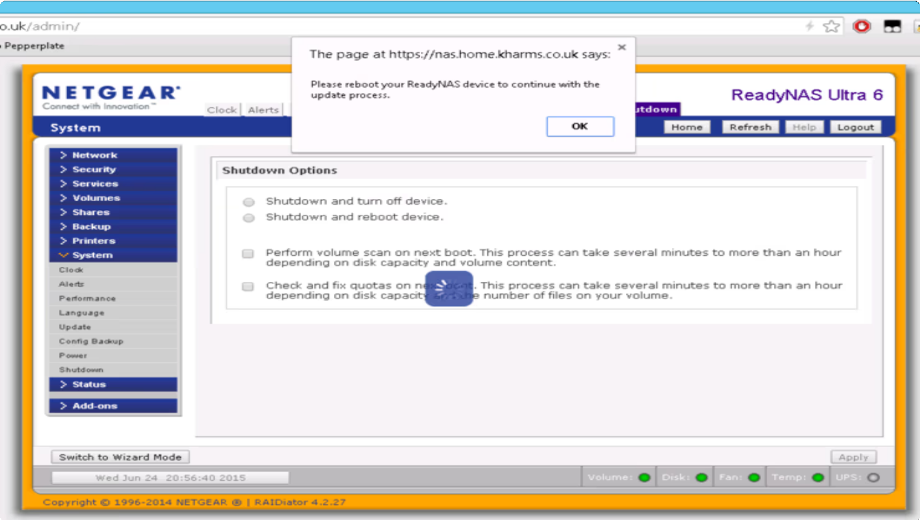

Now we pray to the computing deities and hope that the completely unsupported software upgrade we did on our NAS has not fudged the entire box.
As the box gets reset to factory defaults it will now have a DHCP address - connect to this new address, login with admin and password and set it back up with bonding, AD auth, set up some shares and private Time Machine, etc:
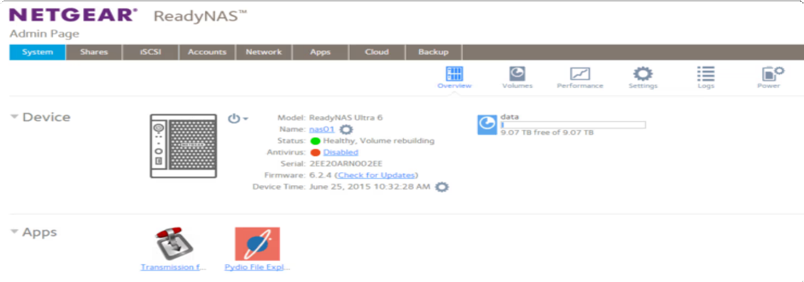

I installed Pydio on mine, it’s an awesome cloud file sync platform that you forward through your firewall (enable IPS on your firewall now if you have it!).
So there it is, nice and easy, updated to the latest RAIDiator. Worth holding your breath during the upgrade for? I think so. Why not follow @mylesagray on Twitter ↗ for more like this!
Netgear
RAIDiator
Readynas

« PREV PAGE
Flashing over OEM-R BIOS/Firmware on Dell hardware

Related content
NEXT PAGE »
Replaying Linux CLI commands with
history

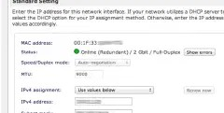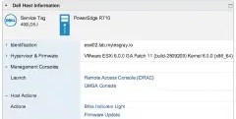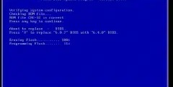

Teaming ReadyNAS Ultra NICs
Deploying Dell OpenManage on ESXi and vCenter 6
Flashing over OEM-R BIOS/Firmware on Dell hardware

53 Comments - powered by utteranc.es
mylesagray commented on 1 sept. 2021
Owner
Comment written by Stephen Monro on 11/05/2015 00:17:03

Have you had any issues since doing this? Did you have to copy all your data back to your NAS and were there any performance issues afterwards?
Cheers,
Steve
mylesagray commented on 1 sept 2021
Owner

Comment written by Myles Gray on 11/05/2015 22:45:03

Steve, no performance issues to report, using it as a host for 30 VMs (only lab) at the moment, little latency, nothing crazy though, for normal day to day, should be fine.
Myles
mylesagray commented on 1 sept. 2021
Owner
Comment written by Stephen Monro on 11/05/2015 23:49:00

Fantastic. I may get around to doing it one day then. Cheers.
mylesagray commented on 1 sept. 2021
Owner
Comment written by Don on 05/20/2016 18:57:01
I've tried this on my Ultra 2 Plus and it works, but I have to manually install app (vice using the graphic interface) Did you have the same problem? Should I reinstall or have I missed a setting?
mylesagray commented on 1 sept. 2021
Owner
Comment written by Myles Gray on 05/21/2016 08:35:05

No I just used the UI and it worked
mylesagray commented on 1 sept. 2021
Owner
Comment written by Don on 05/23/2016 19:18:49
I performed the factory reset and rebooted the box. The Ultra 2 Plus now performs as you described. All functions in the GUI work as if the unit was sold with the 6.5 (Current) IOS. Thank you for the follow up.
mylesagray commented on 1 sept. 2021
Owner
Comment written by Yann K. on 06/12/2016 11:06:15

Hi guys,

Thanks Myles for leaving your experiments here. I have an old Ultra2 with an old Debian 4.x something.
My disks are full of 20+ years of emails and pictures. I'm fed up with the old Debian. I wanted to
change the release. I didn't find a clear statement of what needed to be saved ? On my older

ReadyNAS Duo, there were no extra disk for the system. Same here ? Cheers. Yann
mylesagray commented on 1 sept. 2021
Owner
Comment written by Myles Gray on 06/12/2016 11:31:32

Hi Yann, The upgrade will wipe everything you'd need to backup or migrate all data off. M
mylesagray commented on 1 sept. 2021
Owner
Comment written by Yves on 09/22/2016 14:11:09

Hi!
Thanks for your article, did you upgrade to the latest updates (like 6.5.2) since then without problem? Cheers, Yves
mylesagray commented on 1 sept. 2021
Owner
Comment written by Myles Gray on 09/22/2016 15:17:10

Yep and they worked seamlessly.
mylesagray commented on 1 sept. 2021
Owner
Comment written by Yves on 09/22/2016 16:02:50

Glad to read that.

Unfortunately I just tried upgrading my ReadyNas Ultra 2 from 4.2.30 to OS6 following your instructions but it fails on step 1, saying it 'couldn't extract files properly' from the "R4toR6_Prep_Addon.bin"...
Njo chance here
mylesagray commented on 1 sept. 2021
Owner
Comment written by Yves on 09/22/2016 17:13:36
UPDATE: I did a Factory Reset after a backup, and now it's upgrading to OS6. Yipee! Thank you very much for this article!

Comment written by Myles Gray on 09/22/2016 17:14:39

Not a problem Yves!
Owner
mylesagray commented on 1 sept. 2021
mylesagray commented on 1 sept. 2021
Owner
Comment written by Ricardo Arredondo on 09/25/2016 10:09:07
Work was getting rid of a ReadyNAS 2100 v2 decided it would behouve me to use this since my FreeNAS box was acting bonkers. Did the upgrade as explained and its working fine for me.
mylesagray commented on 1 sept. 2021
Owner
Comment written by Ahmet Özcan on 10/10/2016 06:47:02

Thank you very much, a great job.
I did the update on my ReadyNAS 2100. Every thing work fine, so it seems...

Two things:
- The USB devices will not get mounted. Any advise?
- Movies are no longer played smoothly
mylesagray commented on 1 sept. 2021
Owner
Comment written by german811 on 11/24/2016 02:43:16
Hello, you think it will work on my readynas Ultra 4 with 4.2.30?? i have 4 disks of 2tb each. Regards
mylesagray commented on 1 sept. 2021
Owner
Comment written by Myles Gray on 11/24/2016 20:20:01

Probably just expect it to wipe the box
mylesagray commented on 1 sept. 2021
Owner
Comment written by nvgoldendog on 01/28/2017 09:42:04
Do you know if this firmware will work on the original Silver color ReadyNAS NV+ RND4425-100NAS? I was reading somewhere that this model has a Sparc processor, but maybe the firmware you are talking about is for a Sparc processor? Just want to make sure before I brick my old ReadyNAS NV+.

mylesagray commented on 1 sept. 2021
Owner
Comment written by Myles Gray on 01/28/2017 09:51:29
I have it installed on my Ultra 6, which uses an atom x86 proc, would be surprised if it worked on SPARC
mylesagray commented on 1 sept. 2021
Owner
Comment written by Frank Hall on 02/07/2017 01:55:31

Thank you!!!!!!
mylesagray commented on 1 sept. 2021
Owner
Comment written by Vasanth on 03/29/2017 00:02:52

Do we have similar file for RND4000v2 since this works only for x86 architecture.
mylesagray commented on 1 sept. 2021
Owner
Comment written by Petter Straumsheim on 06/08/2017 19:36:45

Will this work on the ReadyNAS NVX RNDX4210?
mylesagray commented on 1 sept. 2021
Owner
Comment written by Myles Gray on 06/08/2017 20:09:21

Should work on any ReadyNAS with an x86 CPU
mylesagray commented on 1 sept. 2021
Owner
Comment written by Lee on 06/12/2017 05:16:11
Going to try this this weekend , my question where or what would be the best place to save 2tb of info to
mylesagray commented on 1 sept. 2021
Owner

Comment written by Petter Straumsheim on 06/25/2017 02:22:59

Is there anyway you could send me the files i need? I cant seem to find them anymore since the netgear site redirects me to they're homepage.
25 hidden items Load more...

TheSandshark commented on 3 juin 2024
There is plenty of more recent information in Netgear's ReadyNAS forum. Just don't try and use the absolutely abominable native search, use Google. The issues you've come across were solved long ago.  In 6.10.10, they disabled app installation because Debian Jessie has been archived. If you want to still be able to run apps, then don't go past 6.10.9. But you still have to make some changes via SSH to point to the archived Debian repositories and accept outdated signatures in order to add anything. They also disabled ReadyCloud since it's no longer available. So that's a good thing about  6.10.10 as long as you don't need apps. No reason to go earlier than 6.10.9 with 2GB of RAM, but you can convert to something earlier and then update if that's easier for you.  Your Ultra4 is still up to the task, except maybe for some add-ons like Plex with transcoding enabled. It's more powerful than some of the older entry-level native OS6 ARM based units.  But before you do anything, back up your VPD file. (see https://community.netgear.com/t5/Using- your-ReadyNAS-in-Business/Backup-and-restore-of-VPD-file-for-legacy-ReadyNAS-running- oS6/td-p/2253308). 6.10.x installation seems to corrupt it a lot more than previous versions, and Netgear no longer has anyone that will replace it for you. If it's corrupted, you can't boot ReadyNAS OS (6.x or 4.2.x).  Netgear has exited the NAS market, so you probably want to start looking elsewhere for a replacement But OS6 on a ReadyNAS is still workable even on a legacy unit at least for home use |   
hoadie72 commented on 5 juin 2024
Thanks for your feedback, that gives me a lot to think about. The thing with this NAS is it's worked perfectly fine for many many years, and the only issues I've ever had have been with the HDDs failing over time. I've never lost any data during rebuilds. My current problem is having to resort to older browsers to manage it (due to the TLS issues) and struggling to find a solution alerts to be emailed. I
suppose I'll have issues with 6.x at some stage too.
SpaceJocky87 commented on 10 juin 2026
I successfully updated my ReadyNAS Pro 4 using this method today. I got a bit scared at reboot I saw a message about a "failure to extract". but after leaving the unit a good 10 minutes the firmware and OS installed and seems to be working perfectly. I have yet to upgrade the 1gb of ram that shipped
with it originally.

 | Write | Preview
Sign in to comment

Styling with Markdown is supported Sign in with GitHub

© 2026 Blah, Cloud Powered by Hugo & BurgerMod

